|  |
| --- |
| Bayer Healthcare |
| Doc41 Web UI Administrator Guide |
| Usermanagement |
|  |
| **Ingo Kaulbach (Bayer Business Services GmbH)** |
| **28.10.2013** |

|  |
| --- |
|  |

Content

User management 2

Overview 2

Create Bayer internal user 3

Create external user 4

Edit User 6

Internal 6

External 6

# User management

## Overview

This screen shows an overview of all users.

The users can be filtered by entering values in the header filter fields.  
The users can be sorted by clicking on the in the header fields.

The first icon indicates the status of the user: green for active, red for inactive. This status can be toggled by clicking the red/green icon in the last column. The icon in the second to last column opens the edit dialog.

There are two buttons to create an internal or external user.

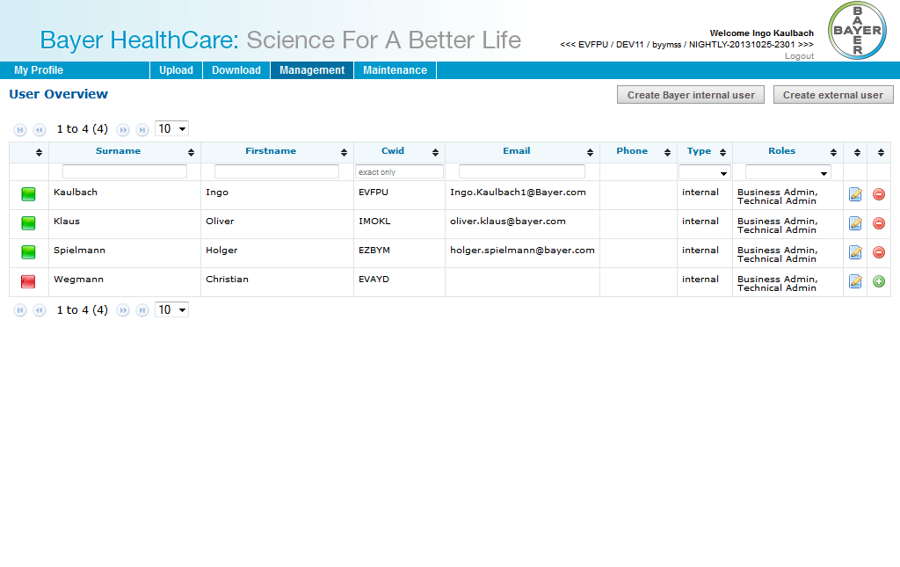

## Create Bayer internal user

This screen is used for importing internal (=Bayer) users into the system. After a CWID is inserted and “Create Bayer internal user” is clicked, the Import Screen will be shown.

Time zone, language and status of the user have to be set. Only active users can log into Doc41WebUI.

An internal user can have following roles:

* Business Admin
* Technical Admin
* *Observer*

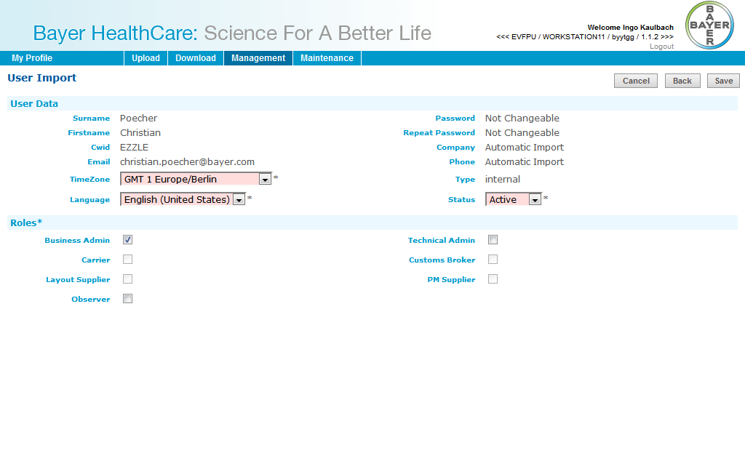

Cancel will go back to user overview.  
Back will go back to enter another CWID.  
Save will create the user.

## Create external user

This screen is used for creating external users into the system.   
For external users First-, Surname, Email-Address and Password must be entered.

Time zone, language and status of the user have to be set. Only active users can log into Doc41WebUI.

An external user can have following roles:

* Carrier
* Customs Broker
* Material Supplier
* Product Supplier
* Viewer Country
* Viewer Customer
* Layout Supplier
* PM Supplier
* *Observer*

An external user can have Partner Numbers, Countries and Plants.  
Partner Numbers are only numbers (no letters etc.). After click on “Add”-button the partner will be searched in SAP and added to list, if found.  
Countries can be added from a list.  
Plants can be added as text. A Plant must only have numbers and upper case letters and a maximum length of 4.

Cancel will go back to user overview.  
Save will create the user.

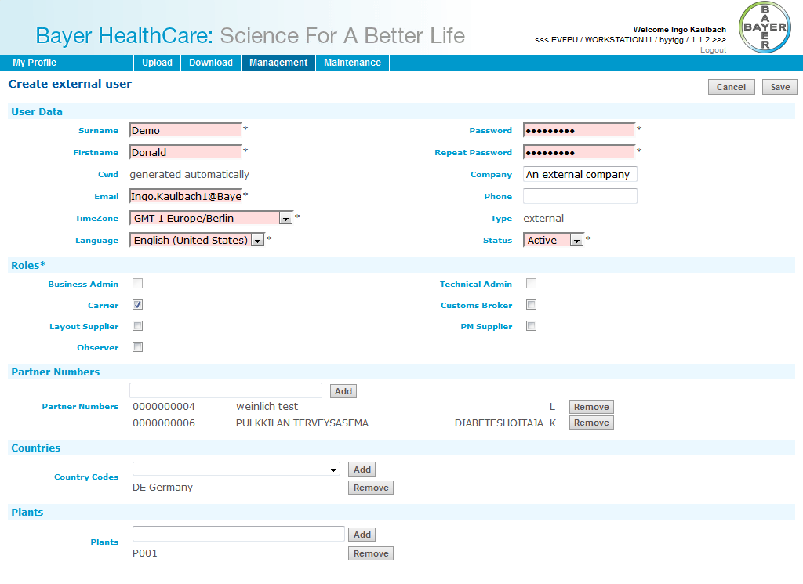

## Edit User

This dialog is used for existing internal/external users. It looks like the User Import or Create external user dialog.

### Internal

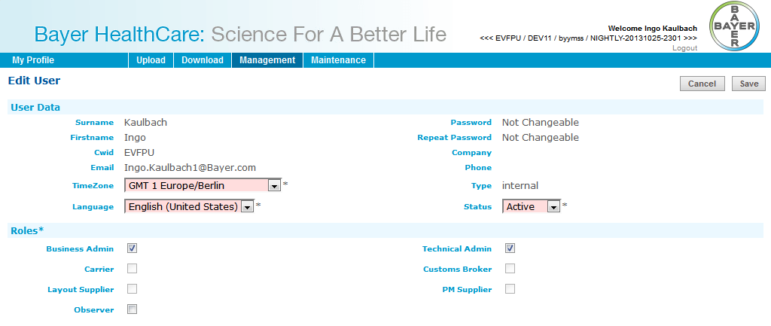

### External

